### **Create a User and Organization**

You need to perform two actions in order to configure Chef Server 12:

* Create an admin user
* Create an organization

Both of these actions are now

* chef-server-ctl subcommands: user-create and org-createrespectively.

##### **Step 1: In order to link workstations and nodes to the Chef server, an administrator and an organization need to be created with associated RSA private keys. From the home directory, create a .chef directory to store the keys:**

# mkdir -p /etc/chef-server/

##### **Step 2: Create an administrator.**

Run the following command to create an administrator:

# chef-server-ctl user-create admin Vishwa Naik SVishwanatha.Naik@itcinfotech.com root1234 --filename /etc/chef-server/admin.pem

**Syntax Explanation:**

$ chef-server-ctl user-create USER_NAME FIRST_NAME LAST_NAME EMAIL 'PASSWORD' --filename FILE_NAME

##### **Note :** An RSA private key is generated automatically. This is the user’s private key and should be saved to a safe location. The --filename option will save the RSA private key to a specified path.

##### **Step 3: ensure admin.pem file is listed in your below directory**

# ls /etc/chef-server/

##### 

##### **Step 4: Create an organization.**

Run the following command to create an organization:

# chef-server-ctl org-create cloudenabled "cloudenabled pvt ltd." --association_user admin --filename /etc/chef-server/cloudenabled.pem

# ls –lh /etc/chef/server

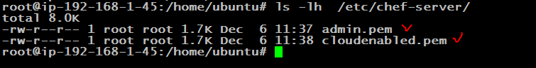

**Syntax Explanation:**

$ chef-server-ctl org-create short_name 'full_organization_name' --association_user user_name --filename ORGANIZATION-validator.pem

Note

The name must begin with a lower-case letter or digit, may only contain lower-case letters, digits, hyphens, and underscores, and must be between 1 and 255 characters. For example: 4thcoffee.

The full name must begin with a non-white space character and must be between 1 and 1023 characters. For example: 'Fourth Coffee, Inc.'.

The --association_user option will associate the user_name with the admins security group on the Chef server.

An RSA private key is generated automatically. This is the chef-validator key and should be saved to a safe location. The --filename option will save the RSA private key to a specified path.

Note : In both cases, use the --filename parameter to write the *.pem files containing the user and organization keys. By default, they are just echoed to STDOUT.